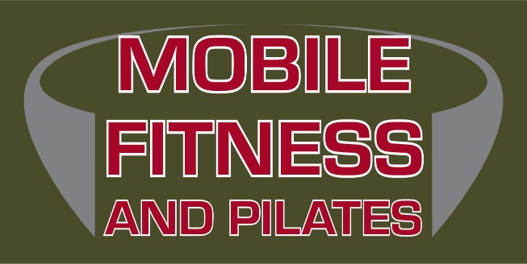
Fiona Hermanutz
43 Mission Ave
St Albert AB
780 668 1910
www.mobilefitnessandpilates.com
MOBILE FITNESS AND PILATES
INDEPENDANT RECOVERY PILATES PROGRAM
Our instructors are movement specialists trained in the art of designing specific Pilates programs with the guidance of physiotherapists, occupational therapists, and other allied health professionals. Our aim is to assist clients in reducing pain, promoting healing post injury, and rehabilitating safely following orthopedic surgery and/or cancer treatments. We aim to help clients gain self-empowerment through 2 initial one-on-one sessions and subsequent Mini Independent Pilates Programs that are designed to meet the needs of each individual. These mini sessions will be 30 minutes long. During these mini sessions, there can be 2 to 5 people in the studio working on their own program at any given time with the guidance of our Pilates Instructor. There will be numerous times available throughout the day to attend.
If your goal is to:
- Recover from an injury and/or surgery
- Manage musculoskeletal pain (incl. low back pain and neck/shoulder pain)
- Manage symptoms of arthritis
- Manage pregnancy-related pelvic girdle pain
- Improve your training edge in sport or dance
- Maintain your strength, flexibility, and balance by establishing a regular body maintenance routine
- Strengthening the body to return to work
We use the principles of classical Pilates techniques, combined with contemporary evidence-based practice and referrals from various allied health professionals to implement these mini sessions.
Specific Conditions and Populations:
- Hypermobility and/or Joint Instability (e.g. chronic ankle instability)
- Chronic Pain Conditions
- Arthritis
- Low Back Pain Management
- Neck and Shoulder Pain Management
- Joint Replacements
- Post-op Rehabilitation (e.g. ACL surgery, meniscus repair, and arthroscopy)
- Cancer Treatment/Surgeries
- Sport-related and Recurring Injuries
- Balance and Mobility
- Whiplash Injuries/Car Accident Soft Tissue Injuries
Getting started:
It is our intention to cater to each individuals needs. We start with 2 private sessions to create a personalised program of exercises aimed at addressing your specific condition and goals. If you are a client already moving with us, we will chat about your goals and only need one private. All you need to do is connect with us and book a time to meet for your initial one-on-one session. If you are a referral from an allied health professional, we will touch base with your therapist to assist in creating the best plan we can for you (we will need your approval to do this). From there, we will design and teach you your program! During your second one-on-one session, you will be learning how the equipment works, how to adjust the springs, and how to effectively perform each exercise.
After your initial private sessions:
After you have learned your program in one-on-one sessions, you can move into supervised 30-minute group sessions. These groups are a minimum of 2 people with a maximum of 5 people. Each person will have their own program, and a Pilates Instructor will be there supervising the session to ensure you are doing each exercise safely and effectively. The instructor is there to assist with equipment/spring adjustments, and to guide you through strengthening your body and refining your movements.
Some Common Questions:
- How do I get started?
Contact us at the studio to book your first initial session/appointment. It will take 2, one-hour sessions to assess your movements and teach you the program. If you are a referral, we ask that you have your therapist contact us with any specific contraindications or details they would like us to know. You will need to give your therapist approval to discuss your specific needs with us.
- When can I start after my initial program set up appointments?
The following week we will have your program ready to go! You can then book and join the 30-minute, mini group sessions.
- How many times a week should I attend?
This is up to you. We would love to see you two to three times a week. Maintaining consistency is a critical component of successful rehabilitation and results!
- What if I can not remember my movements or exercises?
During each session, you will be provided with a printed checklist of your entire program laid out for you to follow. Additionally, there will always be an instructor in the studio assisting you and the other clients (max 5) as you work through your individual program.
- How long are the sessions?
30 minutes including a warmup
- Do I need to share any equipment?
Absolutely not! You will have all the equipment you need to complete your program (incl. reformer, tower, resistance bands, etc.).
- Will I get more exercises and changes in my program as I progress?
Yes, we will re evaluate as you continue to move. If you have been referred to us, we will also keep in contact with your allied health professional to ensure we are complying with any condition changes.
- How do I book my sessions?
You can contact us by email or text to book in; or book follow-up sessions at the end of each session you attend.
- How do I purchase my sessions?
We offer a punch card system. When you attend, we will punch your pass.
- How much do the sessions cost? Is there a cancellation policy?
- The initial set up of the program including the 2, 60-minute sessions plus the design of your program is $220 plus GST.
- The 30-minute mini sessions are:
1 PASS - $25
5 PASS - $110
10 PASS - $200
- Cancellation policy – we require 8-hours notice upon cancellation of the session or the session will be charged.
- Is there coverage for these sessions?
We have had allied health professionals (e.g. physiotherapists) put in requests to specific insurance companies for coverage depending on the situation. (car accidents) Ask your therapist if this might be an option for you. If you have a benefit plan that includes a “Health Spending Account” you also might be able to get a portion of the sessions covered. We at Mobile Fitness are not able to direct bill.
- How long can I continue these mini sessions?
This is completely up to you. We hope that these sessions allow you to eventually progress to group fitness classes, including our regular group class schedule. We offer several different levels of classes from Gentle Corrective Classes right up to Advanced Level Classes. However, if you prefer to continue with mini session, you are more than welcome to! We truly offer something for everyone!

